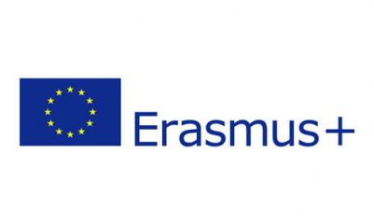 | Certificate of Attendance | 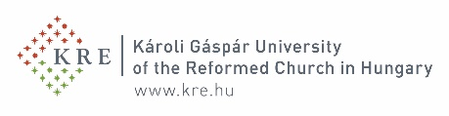
Erasmus+ Programme, Student Mobility for Studies or Student Mobility for Traineeships

Name of the exchange student
Field of study
Home University
Host University | Károli Gáspár University of the Reformed Church in Hungary
Faculty/Department

Confirmation of arrival
We confirm that the above mentioned student has arrived at our University and has started his/her studies
on (dd/mm/yyyy) | 05/09/2022
Responsible person at the Host University | Name: Virág Zombory
 | Position: International coordinator
 | Email address: erasmus@kre.hu
Date | 05/09/2022 | Stamp
Signature
(The student has to send this document to the institutional Erasmus coordinator within 14 days after the arrival.)
Confirmation of departure
We confirm that the above mentioned student has completed his/her studies and is leaving our University
on (dd/mm/yyyy) | 06/02/2023
the academic Transcript of Records | is enclosed
 | will be sent directly to the International Office of the Home University
Due to the COVID 19 pandemic, our University offered studies and activities for incoming students as follows: | - on Campus (in-person activities): from ___/____/____ to ___/____/_____  - virtual activities (online): from ___/____/_____ to ____/____/______
Responsible person at the Host University | Name: Virág Zombory
 | Position: International coordinator
 | Email address: erasmus@kre.hu
Date | 06/02/2023 | Stamp
Signature

